Some general comments

- the term 'follicle development' got me very confused. You are using it in a rather restricted sense of growth and development of the follicles after but not including initiation. You use it when you refer to the effect of collagen on curvature and alignment. You do not mean to refer to the common effect of fibroblasts on ppcells and on collagen, but I got confused. Can we invent a term that makes it clear – maybe 'follicle development after initiation' or maybe 'follicle maturation' or whatever

- the other business – about fibroblasts and ppcells and fibril formation comes in very late in the paper. So the 'tradeoff hypothesis' does not feature as much as the 'interference hypothesis'. Is that what you intended?

- the third hypothesis ( folding due to tension between expanding papillary layer and bonded collagen layer) seems to be fitted in pretty well.

We are proposing three things. Should we make this clear at the start or where? They need to be brought together somewhere. One place would be the last paragraph maybe.

- There are lots of measurements in Tables 2,4 which are not defined. The easy way to do this is in the Methods with a Table of Measurement definitions. It needs Name, Description, Units for each measure.

**Collagen paper: revised version, 20 June 2018.**

**Is collagen quantity and properties involved in wrinkle formation and follicle development ?**

**Abstract**

In Merino sheep with wrinkly skins, collagen is present as thick, enmeshed sheets of hard (Type I) collagen fibrils located in the papillary dermis immediately below the follicles. It also surrounds the follicle bulbs. The hard collagen layer appears to be continuous throughout the skin with no difference in collagen content and type measured for sampling sites, “on wrinkles” and “between wrinkles “. The overlying follicle groups are severely disrupted. The follicles are highly curved and uneven in depth. The secondary fibres are high in mean fibre diameter, and highly variable in fibre diameter and fibre length.

In non-wrinkly Merino sheep with loose and supple skins, much less collagen is found in the papillary dermis below the follicles. The collagen is mainly soft (Type III) collagen and is arranged as a reticular pattern of thin sheets. The follicle groups are well-defined and arranged in orderly, well-spaced rows. There are higher numbers of follicles per group, and higher follicle densities, than in the wrinkly skin sheep. The follicles are straighter and more even in depth. The secondary fibres are finer and less variable in diameter and length.

 We propose that wrinkle development in the foetus interferes with secondary follicle development.

Not exactly. It is collagen development ( I think) that interferes, and also causes wrinkle. Or are you actually saying that the folding itself interferes physically? Maybe, but I dont think you meant that?

You are right. I meant to say that it is collagen development that interferes with secondary follicle development, and also causes wrinkle.

When a lot of follicles initiate, the upper papillary dermis expands considerably. When a lot of hard collagen fibrils form in the dermis below, it binds the dermis against expansion. The conflict between these two tensions causes the epidermis and dermis to fold. Only sheep with both a high follicle number and a high content of hard collagen develop wrinkle. This an epistatic effect where the genes for follicle number interact with the genes for collagen development.

Yes this para about the wrinkle formation hypothesis is the main bit.

The interference hypothesis is a side effect. Keep it separate. And where is the tradeoff bit?

Wrinkles appear as vertical lines overlapping and descending from the origin points of the spinal nerves, conforming to the dermatome patterning established in embryogenesis.

**Introduction**

One of the authors (JW) has developed a Merino sheep (referred to as “SRS”) with a loose and supple skin, completely free of skin wrinkle, which grows a distinctive fleece type. He has shown that these sheep can be identified subjectively with considerable accuracy and that these sheep produce fleeces of high quantity and quality (Watts et al, 2017). The sheep are naturally resistant to fly strike and do not require to be mulesed (Watts, 2008 a,b; Watts, 2016). The skin type has a distinctive follicle patterning which comprises orderly rows of compact follicle groups with a high secondary follicle to primary follicle (S/P) ratio due to compound follicles having more branches, and fine and long primary and secondary fibres which are softer than normal wool (reference). The question arises as to why it was necessary

in SRS breeding for the skin to be wrinkle-free ?

Changes made.

Most Merino sheep have wrinkly skins. Wrinkles are raised and often hardened areas of skin (Figure 1). Wrinkles form when the epidermis, papillary dermis and reticular dermis buckle up into a fold, while the underlying areolar/muscle layer and adipose tissue layer remain straight (Figure 1).

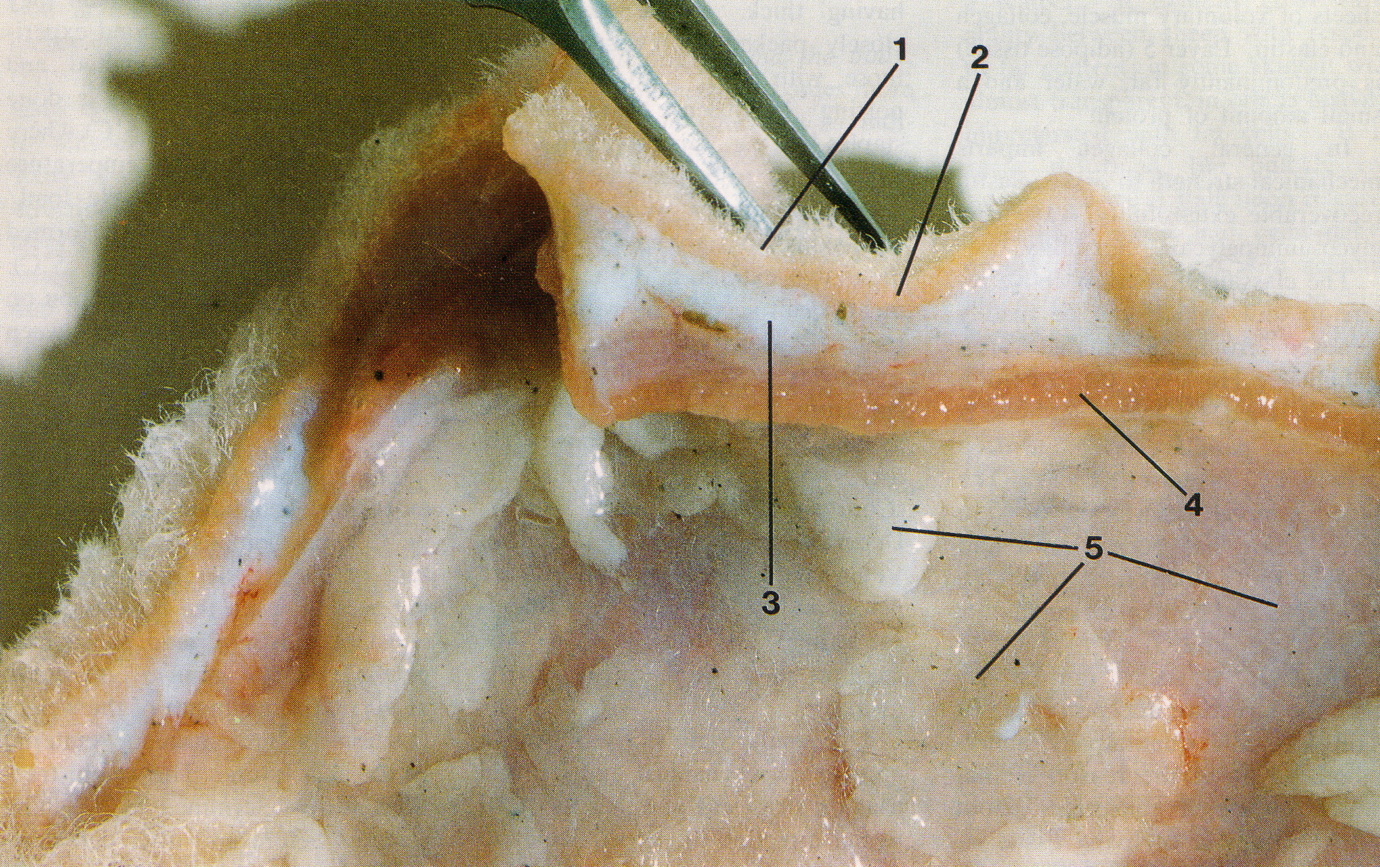

**Figure 1. Merino sheep skin showing layers. 1. epidermis with wool fibres; 2. papillary layer of dermis, 3. reticular layer of dermis; 4. areolar tissue and muscle; and 5. adipose tissue. Two wrinkles are present; one alongside each side of the forceps (modified from Mitchell et al, 1984).**

Collagen is the major component of connective tissue of the skin (elastin and reticulin are minor components). It is present in foetal sheep skin at 75 to 80 days; the time when wool follicles develop (Knight et al 1993). These authors distinguish two collagen types, namely Type III or ‘soft collagen’ and Type I or ‘hard’ collagen. They report that Type III collagen is highest at 75 days of gestation, and falls progressively as the foetus develops, while Type I collagen is low at day 75 and rises to over 50 percent by birth.

Collagen fibrils are formed from cells called fibroblasts. At 75 to 80 days of foetal life, the fibroblasts are plump, immature cells surrounded by a fine, reticular pattern of collagen fibrils which are composed of Type III collagen. By birth the fibroblasts have matured and the collagen fibrils may be enmeshed to varying degrees. If the fine, reticular pattern of fibrils remains, it appears to be soft collagen and skin wrinkling does not seem to develop. If the collagen fibrils enmesh, lengthen and thicken, the collagen tissue appears to be hardened.

Bogolyubsky (1940) observed that wrinkles develop in the foetal skin of Merino and Karakul lambs at 100 days of gestation; first on the dorsal surface and then extending down the sides to the belly. From these observations, Jackson and Watts (2017) have put forward the hypothesis that because wrinkles form in the foetus at the same stage as secondary follicle development, wrinkles would be likely to affect, or be affected by, secondary follicle development. They suggest that in sheep skin with wrinkle development, there is likely to be more hard collagen in the dermis at the time of wool follicle development. The downgrowths of epithelial tissue which form developing wool follicles have to penetrate and displace the dermal tissue. If the dermis has hard, intermeshed collagen, the follicle downgrowths may not readily penetrate the dermis to full depth, and may grow in a curved shape so that the bulbs are closer to the epidermis. Merino sheep with tangled or curved follicles have more follicle (trio) group distortion and a poorly organised network of blood vessels compared with sheep with straight follicles (Nay 1966).

Change made.

Curved follicles grow curved fibres, with a greater proportion of paracortex, and a more highly keratinised paracortex. The rate and type of fibre growth is a question of the way the bulb cells differentiate to form the fibre cortex in straight versus curved follicles. In curved follicles there is more bilateral asymmetry in the fibre cortex (reference ?).

I think Mercer(1950's) in a textile journal. Will look.

If there is more keratinisation it means bulb cell differentiation into fibre proceeds for longer, so the fibre length growth rate would be slower. If Jackson and Watts’s hypothesis is correct this proposition we expect:

* wrinkled sheep to have more or harder collagen in the dermal layers
* sheep with more or harder collagen to have curved follicles and disruption to the arrangement of follicle (trio) groups
* sheep with curved follicles to grow curved fibres with a more radical segmentation of orthocortex and paracortex
* sheep with curved follicles to have lower fibre length growth rate
* sheep with curved follicles to have a higher secondary fibre diameter
* sheep with more or harder collagen to have follicles of uneven depth
* sheep with follicles of uneven depth may have greater variability of secondary fibre diameter.
* sheep with curved and unevenly seated follicles to have more fibre entanglement in the fleece and consequently form fleece staples of large cross-sectional area

The genetic correlation of wrinkle score with follicle curvature is 0.69 (95 percent confidence limits 0.65-0.74) (Jackson 2017). This suggests, but does not prove that collagen is the linking factor. In the present study we have collagen measurements and we have follicle curvature scores, so testing the above expectations can be done. What is proposed here is that collagen development in the skin might be a common factor with both wrinkle development and follicle development.

Yes that says it better.

**Materials and Methods**

**Sheep studied**

Merino sheep were studied. Two trials were conducted. Details are shown in Table 1.

Table 1.

|  |  |  |  |  |
| --- | --- | --- | --- | --- |
| Trial | Flock no. | Age of sheep (months) | Sex of sheep | Number of sheep |
| 1 | 1 |  | rams | 2 |
|  | 2 |  | rams | 2 |
|  | 3 |  | rams | 2 |
|  | 4 |  | rams | 2 |
|  | 5 |  | rams | 2 |
|  |  |  |  |  |
| 2 | 6 |  | ewes | 18 |
|  | 7 |  | ewes | 18 |

We do not have 'loose' or 'tight' in this table. That is part of the design, it had better go in.

In trial 1, a loose and supple skin sheep was compared to a wrinkly skin sheep from five Merino flocks. The skin samples had been trimmed so that only layer 1 (epidermis) and layer 2 (papillary dermis) were available for histological observation and measurement.

In trial 2, nine sheep with loose skins were compared with nine sheep with wrinkly skins, in each of 2 flocks. Wrinkle development was more accentuated in flock 7 than in flock 6. For the sheep with wrinkly skins, measurements and scores were made for skin samples collected from on the wrinkles as well as between the wrinkles. The skin samples included layers 1 to 4.

**Gross examination of sheep**

In trial 2 the number of wrinkle lines originating immediately adjacent to and on both sides of the spinal column, and extending from the base of the skull to the base of the tail, were counted for each sheep. The direction each wrinkle was tracking, was recorded.

**Skin samples**

Midside skin samples were collected using a 10 millimetre circular trephine (Acu Punch® skin biopsy punches, Acuderm, Inc.) and fixed in 10% formol saline solution.

Skin samples were washed in several changes of water, the wool stubble trimmed and then examined under a magnifying lamp ( x 3 magnification). Scores for suppleness (1 = hardened to 5 = supple) of the papillary layer and reticular layer were made. Each skin sample was examined to determine if layers 2 and 3, and layers 3 and 4, were free or fixed and whether localized hardening and folding of the skin had occurred.

The thicknesses of the papillary dermis and the reticular dermis were measured using a ruler graduated in one millimetre divisions. A Mitutoyo ballpoint gauge (model no. 2046S) was then used to measure the compressed thickness at four sites for each skin sample.

**Histology**

Punch biopsy skin samples were fixed in 10% neutral buffered formalin for 24 hours before being processed to wax in an automated tissue processing platform (Shandon Excelsior, Thermo Scientific, USA), and then embedded in paraffin wax. Four micron sections were cut and placed onto slides for subsequent haematoxylin and eosin (H-E) staining for tissue morphology. Serial section was also employed on a separate slide for picrosirius red (PSR) staining to highlight collagen content. Staining was performed manually.

Sections were then reviewed microscopically (BX53 Olympus, Australia)), and images taken on 3 CCD camera (DP72, Olympus, Australia) under both bright field and polarized conditions for PSR staining.

For PSR collagen analysis, the 40x objective was employed at a fixed exposure to take high power images of 5 random deep dermal fields of view for computational analysis.

The images for each sample were then uploaded for quantitative analysis via the ImagePro Plus (Media Cybernetics, USA) 7.1 software in which thresholds were set to count all pixels comprising of the red staining fibres in the PSR stained specimen against the total pixels. A mean was calculated for each of the specimens’ 5 images and they were graphed.

Polarised light was employed in order to try and determine the type of collagen present within each of the samples. Bright apple green birefringence was visualized in the loose skin samples, in contrast to the wrinkled skin samples, in which the fibres tended towards red/orange birefringence.

Vertical skin sections, approximately 0.3 millimetres wide, were cut freehand with a sharp razor blade on a freezing stage and stained with 0.25 % Nile blue sulphate, as described by Nay (1973). The sections were cut parallel with the angle of emergence of the fibres to avoid cutting through follicles. Mean follicle curvature was scored from 1 = straight follicles to 7 = tangled follicles by reference to a set of standard drawings used by Nay and Johnson (1973). Follicle depth was measured as the angular distance (in millimetres) between the skin surface and the lower ends of the follicle bulbs.

Horizontal skin sections were prepared as described by Maddocks and Jackson (1988) using the frozen section technique and measurement procedures of Nay (1973). The sections were used to measure follicle density, S/P ratio, primary fibre diameter and secondary fibre diameter of the sheep.

JW to describe measurement of orientation of follicle groups and measurements made of collagen sheets in subfollicular layer of papillary dermis.

**Results**

**Trial 1**

**Collagen content, distribution and type**

Observations and measurements were restricted to the papillary dermis (layer 2).

Collagen content of the papillary layer below the follicles is shown diagrammatically in Figure 2. The measurements are listed in Table 1.

**Figure 2. Collagen content of subfollicular region of the papillary dermis of loose skin sheep and wrinkly skin Merino sheep.**

Loose and supple skin sheep have lower collagen content than wrinkly skin sheep. In flocks 1 to 3, the differences were highly significant (P<0.001) and significant in flocks 5 (P < 0.01) and 6 (P< 0.05).

No units on Y axis, and needs 'Flock No' on X axis. If that is difficult in the Figure, put it in the caption.

The 5 sheep with wrinkly skins have thick and enmeshed collagen sheets throughout the subfollicular region of the papillary dermis. The thick collagen sheets also surround the follicle bulbs and are found between the follicles. The follicles are highly curved and unevenly seated. Birefringence measurements of PSR stained skin sections indicate that nearly all (…. %) of the collagen sheets in the subfollicular layer of the papillary dermis have the deep red light reflectance indicative of hard (type I) collagen. (Sanaz, please check this statement).

The 5 sheep with loose and supple skins had thin collagen sheets arranged as reticular patterns and confined to the subfollicular region of the papillary dermis. The follicles are straight and evenly seated. Birefringence measurements of PSR stained skin sections indicate that … %, …. % and …. % of the collagen sheets in the subfollicular layer of the papillary dermis have deep red, yellow and green light reflectances respectively. The yellow and green reflectances are likely to indicate soft (Type III) collagen (Sanaz, please check this statement).

**Follicle and fibre disruption and skin suppleness**

Loose and supple skin sheep had straighter follicles producing secondary fibres that were finer and more uniform in diameter than were found in the wrinkly skin sheep. The skins of loose and supple skin sheep were scored as more supple and measured as more compressible than the skins of wrinkly sheep (see Table 2).

**Table 2. Collagen content, follicle curvature and secondary fibre diameter of loose versus wrinkly Merino rams in five flocks.**

|  |  |  |  |  |  |  |  |  |
| --- | --- | --- | --- | --- | --- | --- | --- | --- |
| Flock no. | Sheep no. | Skin type | Collagen content | Follicle curvature | Ds | DsSD | Supple score | Compress (%) |
| 1 | W206 | Loose | 150,927 | 3 | 23.8 | 2.9 | 5 | 75 |
|  | W205 | Wrinkly | 311,586 | 6 | 29.5 | 4.2 | 2 | 54 |
| 2 | W490 | Loose | 51,727 | 4 | 22.4 | 3.5 | 5 | 64 |
|  | W479 | Wrinkly | 311,336 | 6 | 22.6 | 3.8 | 2 | 39 |
| 3 | W555 | Loose | 44,415 | 3 | 18.4 | 2.6 | 5 | 67 |
|  | W547 | Wrinkly | 208,267 | 7 | 19.9 | 2.9 | 1 | 58 |
| 4 | W567 | Loose | 109,077 | 3 | 18.6 | 1.8 | 5 | 70 |
|  | W558 | Wrinkly | 209,349 | 3 | 21.7 | 5.3 | 2 | 63 |
| 5 | W283 | Loose | 83,407 |  |  |  | 5 | 69 |
|  | W290 | Wrinkly | 201,825 |  |  |  | 2 | 44 |

**Trial 2**

**Collagen distribution, content and type**

All four skin layers were examined for hard collagen content.

In the papillary dermis (layer 2) immediately below the wool follicle bulbs of the 18 sheep with loose and supple skins, the collagen sheets (multiple fibrils) were thin and arranged in parallel to form reticular patterns (Figure 3). There was no evidence of heavy deposits of hardened collagen in any of the four skin layers. Birefringence measurements of PSR stained skin sections indicate that … %, …. % and …. % of the collagen sheets in the papillary dermis below the wool follicles have deep red, yellow and green light reflectances respectively. The yellow and green reflectances are likely to indicate soft (Type III) collagen (Sanaz, please check this statement). In all sheep with loose and supple skins, the follicles are straight and uniform in depth.

On the other hand, in the 18 sheep with wrinkly skins, only heavy deposits of hard collagen were found in the papillary dermis (layer 2) below the wool follicle bulbs. The hard collagen deposits also encircle the follicle bulbs, as well as surround and infiltrate the muscle bundles of layer 4 (Figure 3). Birefringence measurements of PSR stained skin sections indicate that nearly all (…. %) of the collagen sheets in the subfollicular layer of the papillary dermis have the deep red light reflectance indicative of hard (type I) collagen. (Sanaz, please check this statement). In all wrinkly sheep, the follicles are highly curved and uneven in depth.

(Sanaz – a corresponding loose skin PSR photo to the one below, that does not show the heavy collagen accumulation – photo to be inserted here)

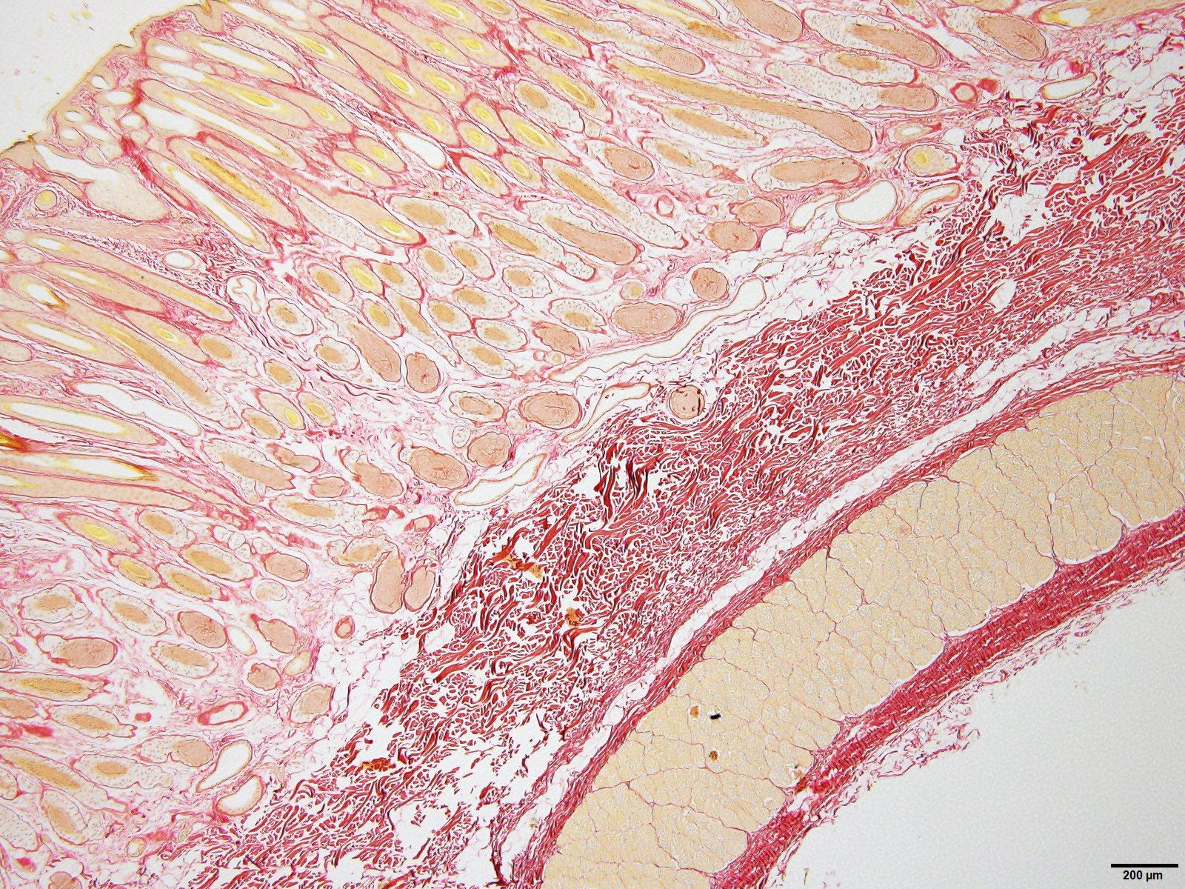

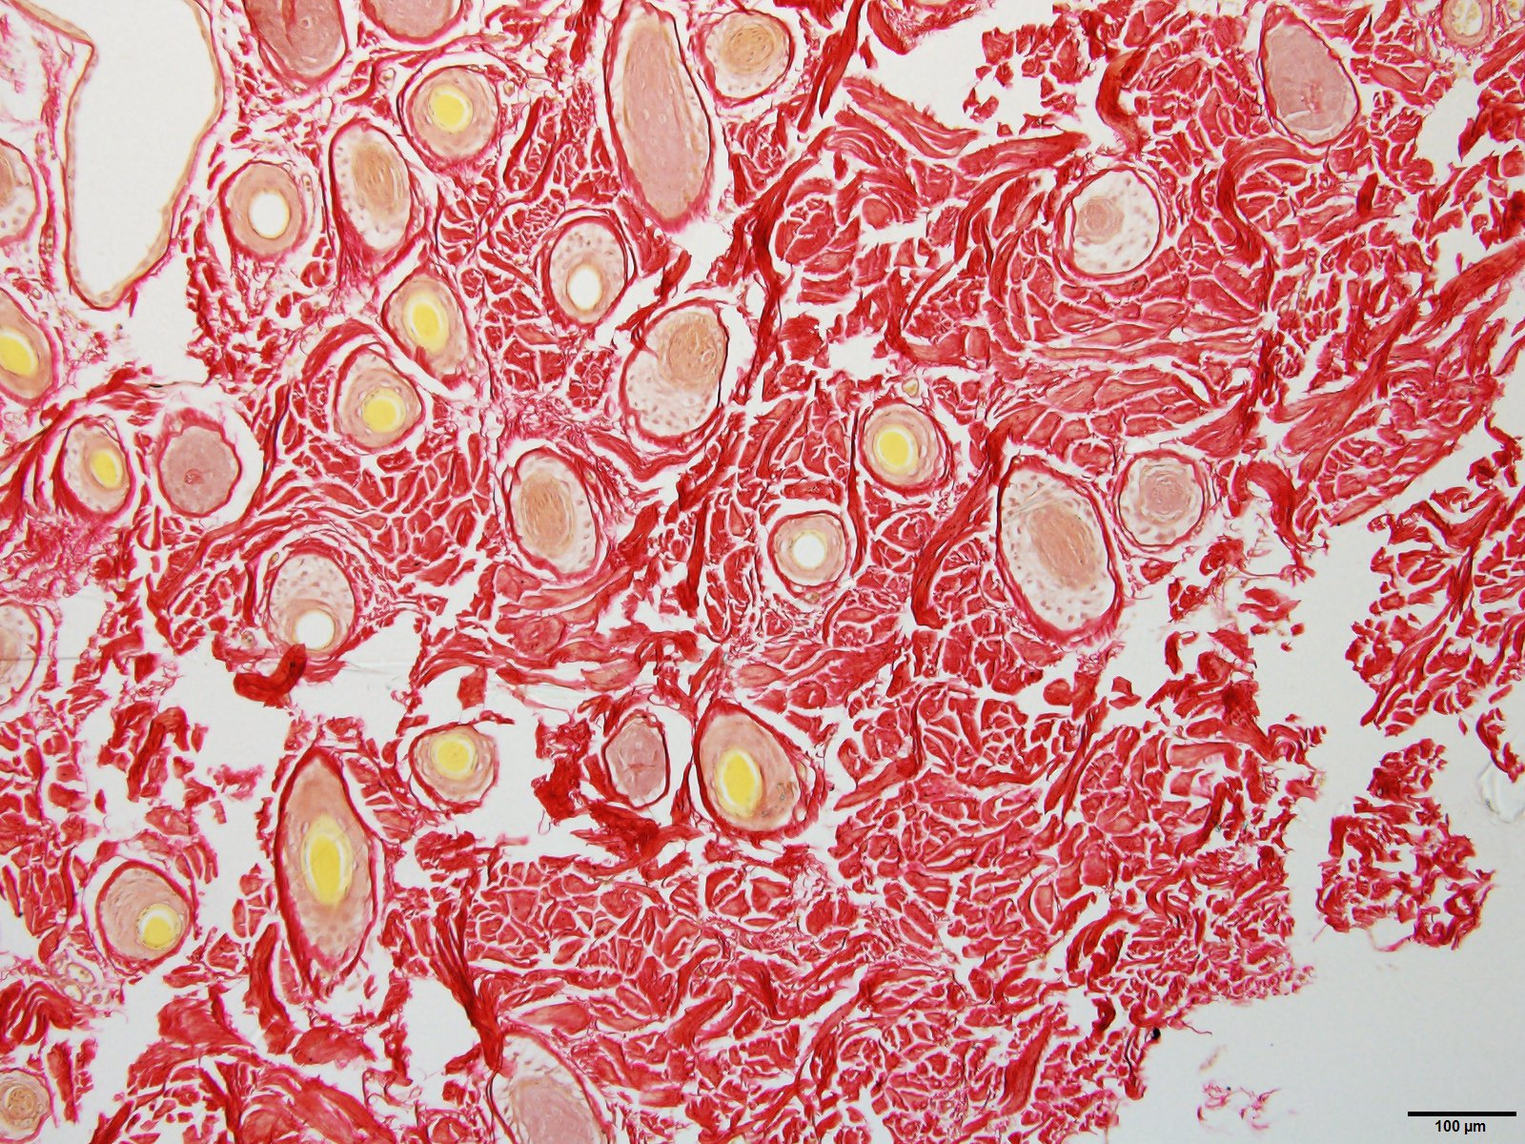

**Figure 3. Vertical sections stained with PSR to show: (top) light collagen development in the papillary dermis below the follicles of a loose and supple skin (x 4 magnification); (middle) heavy collagen development of a wrinkly in the papillary dermis below the follicles of a wrinkly skin ( x 4 magnification) and (bottom) heavy collagen development surrounding the follicle bubs of a wrinkly skin sheep (x 10 magnification).**

The measurements of collagen content of the papillary dermis (layer 2) below the follicles are shown diagrammatically for each sheep in Figure 3. The group means, according to sampling site, are listed in Table 2.

(insert flock 7 (Manton flock) graph here)

**Figure 3. Collagen content of the papillary dermis (layer 2) below the wool follicles of loose and supple skin sheep and between the wrinkles and on the wrinkles of the wrinkly sheep. (Top) flock 6 sheep. (Bottom) flock 7 sheep.**

**Units on Figure again?**

In both flocks, the loose and supple skin sheep have significantly (P < 0.001) less collagen than wrinkly sheep. In wrinkly sheep, there was no significant difference in collagen content for the sampling sites, “between wrinkle” and “on wrinkle”.

In wrinkly sheep, the collagen sheets are more numerous, wider and more enmeshed in the wrinkly sheep than in the loose and supple skin sheep (Figure 5).

Collagen sheets are present in the follicular layer of the papillary dermis

of wrinkly sheep. The sheets are present in great numbers surrounding the follicle bulbs. The follicle bulbs are highly curved (Figure 9).

In the loose skin and supple skin sheep, collagen sheets are restricted to the subfollicular layer of the papillary dermis. Collagen sheets were not found in the follicular layer. The follicles are straight.

Measurements of the width, length and orientation of the collagen sheets in the subfollicular layer of the papillary dermis for loose skin and wrinkly skin sheep are listed in Table 3.

**Table 3. Collagen sheet measurements** (JW to complete measurements).

|  |  |  |  |  |
| --- | --- | --- | --- | --- |
| Flock | Skin type | Collagen sheet | | |
| Width (microns) | Length (microns) | Orientation |
| 6 | loose skin |  |  |  |
|  | wrinkly skin - between wrinkles |  |  |  |
|  | wrinkly skin – on wrinkles |  |  |  |
| 7 | loose skin |  |  |  |
|  | wrinkly skin - between wrinkles |  |  |  |
|  | wrinkly skin – on wrinkles |  |  |  |

(Collagen type – photos, descriptions and measurements here).

**Follicle and fibre disruption**

The group means for follicle, fibre and fleece traits that might be affected by hard collagen development as proposed by Jackson and Watts (2017) are shown in Table 4.

**Table 4. Mean values (and standard errors in brackets) of follicle and fibre measurements for loose skin and wrinkly skin Merino sheep. Within each flock, traits with different superscripts are highly significantly different (P<0.0001).**

|  |  |  |  |  |
| --- | --- | --- | --- | --- |
| Trait | Flock 6 | | Flock 7 | |
| Loose skin | Wrinkly skin | Loose skin | Wrinkly skin |
| Follicle curvature | 1.7a | 3.8b | 2.7a | 5.1b |
| Laneways | 150a (6.5) | 90b (5.3) | 151a (5.5) | 79b (5.0) |
| Follicle group orientation (CV) | 13.3a | 29.2b | 15.2a | 37.5b |
| Dp | 16.4c (0.7) | 18.8d (0.6) | 17.7 (1.0) | 20.5 (1.0) |
| Dp SD | 2.1 (0.1) | 2.6 (0.2) | 2.5 (0.1) | 2.8 (0.4) |
| Ds | 18.4a (0.5) | 20.7b (0.6) | 18.4a (0.2) | 20.7b (0.4) |
| Ds SD | 1.9a | 2.6b | 1.9a (0.1) | 3.7b (0.4) |
| Follicle density | 83.9 (5.8) | 76.7 (4.9) | 94.9c (7.5) | 66.8d (5.8) |
| S/P ratio | 27.8c (1.5) | 21.8d (0.8) | 27.8a (0.9) | 22.6b (1.1) |
| FL | 0.56 | 0.55 | 0.48a (0.01) | 0.40b (0.01) |
| FLCV | 8.0c (0.7) | 10.9d (0.9) | 7.7a (0.8) | 14.5b (1.2) |
| Staple area (mm2) | 6.7a (0.5) | 25.1b (2.4) | 13.1a (1.6) | 27.4b (2.8) |

Within each flock, loose and supple skin sheep differed significantly from the wrinkly sheep for the following traits. The follicles were straighter and more even in depth. The follicle groups were more widely spaced and arranged in more orderly rows. There were more secondary follicles per group (higher S/P ratio). The secondary fibres were finer and more uniform in diameter. The fibres were more uniform in length. The fleece staples were thinner. For flock 7 only, the follicle density was higher and the fibres longer. Whilst the primary fibre diameter was finer in loose and supple skin sheep, the difference was not statistically significant in either flock.

**Skin suppleness**

In both flocks 6 and 7, the papillary dermis of the loose and supple skin sheep is more supple and more compressible than the papillary dermis of the wrinkly skin sheep. The reticular dermis is also more supple and thinner in the loose skin sheep than in the wrinkly skin sheep (Table 5).

Table 5.

|  |  |  |  |  |  |  |
| --- | --- | --- | --- | --- | --- | --- |
| Flock | Sampling site | Papillary dermis | | | Reticular dermis | |
| Supple score | Compress (%) | Collagen | Suppleness score | TST  (mm) |
| 6 | loose skin | 3.8 | 74 | 271,500 | 4.3 | 1.6 |
|  | between wrinkles | 1.9 | 43 | 401,900 | 3.7 | 3.1 |
|  | on wrinkle | 2.9 | 64 | 385,600 | 3.3 | 3.1 |
| 7 | loose skin | 3.5 | 70 | awaiting results | 4.4* | 2.3* |
|  | between wrinkles | 2.1 | 54 | awaiting results | 2.9 | 2.7 |
|  | on wrinkle | 1.9 | 54 | awaiting results | 2.8 | 3.5 |

* Footnote: 18 sheep sampled

In both flocks 6 and 7, the papillary dermis of the loose skin sheep is more supple and more compressible than the papillary dermis of the wrinkly skin sheep. The reticular dermis is also more supple and thinner in the loose skin sheep than in the wrinkly skin sheep.

**Skin wrinkles (including patterns)**

In all 18 examples of skin wrinkles, gross examination revealed that all of these lesions were formed within the papillary dermis (layer 2), like interlocking vertical pillars of hardened collagen. The reticular dermis (layer 3) remained supple (see Table 5) but was still firmly bound to layer 2 in all 9 examples in flock 6 and in 3 of the 9 examples in flock 7.

All of the18 wrinkly skin sheep had wrinkles originating immediately adjacent to the spinal cord in the cervical, thoracic, lumbar and sacral regions of the topline. The numbers of wrinkle lines per body region are listed in Table 6. The mean distance between the lines for each body region is also recorded.

**Table 6. Numbers of wrinkle lines per wrinkly sheep (+/- s.e) and distance between wrinkles (+ - s.e.) in flocks 6 and 7.**

|  |  |  |  |  |  |
| --- | --- | --- | --- | --- | --- |
| Flock | Measurement | Body region | | | |
| Cervical | Thoracic | Lumbar | Sacral |
| 6 | No. wrinkles |  |  |  |  |
| Distance between wrinkles |  |  |  |  |
| 7 | No. wrinkles |  |  |  |  |
| Distance between wrinkles |  |  |  |  |
|  | Number of vertebrae | 8 | 12 to 14 | 5 | 5 |

(Jim Gordon is scheduled to do the skin wrinkle counts and measurements for above Table in mid July).

The skin wrinkling formed a distinct pattern of thin, raised lines coursing as vertical, parallel and equidistant lines down the sides of the sheep (Figure …).



**Figure ….**

The numbers of wrinkle lines matched the number and positioning of the vertebrae in each body region. There was no difference in wrinkle counts on the left and right sides of the sheep.

**Discussion**

We have satisfied most of the expectations of the Jackson and Watts (2017) hypothesis that wrinkle development in the foetal skin interferes with

How about 'interacts with' ? That allows two way effect

Agree.

wool follicle development. Wrinkly sheep, compared with loose and supple skin sheep, have more collagen and harder collagen in the papillary dermis below the wool follicles. The follicles are curved and of uneven depth. There are fewer secondary follicles per follicle group, and the follicle groups are severely disrupted. The follicle density is lower. The wrinkly sheep grow curved secondary fibres of a higher and more variable diameter and a shorter and more variable length. The secondary fibres are more variable in shape and orientation and display more radical segmentation of orthocortex and paracortex. There is more fibre entanglement in the fleece and consequently the fleece consists of staples of much larger cross-sectional area.

Given the above, it is obvious that sheep with loose and supple skin (SRS) have very little disruption of the arrangement of follicle groups, since in an adult horizontal section the follicle groups appear in orderly rows, and the underlying dermis has minimal development of hard collagen tissue.

We know something about the SRS development process. The pre-papilla cell model of Moore et al (1989) and Moore et al (1998) shows that some of the foetal fibroblasts transform into pre-papilla cells. The pre-papilla cells are then directed to aggregate as small “packages” to form many wool follicles that produce fine wool fibres of uniform diameter. This model explains why suppression of the size of primary follicles (and therefore suppression of primary fibre diameter), leads to vastly greater numbers of secondary derived follicles (higher S/P ratio) being formed. In the same

Be more precise

Agree.

sheep type, the fibroblasts that do not transform into pre-papilla cells, appear to be programmed to produce soft (Type 1) collagen rather than hard (Type III) collagen throughout the animal’s life. The superior suppleness scores and compressibility measurements for loose skin sheep compared to wrinkly skin sheep suggest this is the case.

It is the general hardening of collagen in the papillary dermis below the follicles, and not wrinkle per se, that interferes with wool follicle development. So, it is expected that sheep can be plain bodied (wrinkle free) and still have

hard collagen and impaired follicle development. If the skin is not supple and compressible, hard collagen is likely to be present. If the skin has limited dermal expansion

because of low follicle numbers, wrinkles are unlikely to develop.This is what would seem to happen in Downs Wool sheep breeds.

The reticular dermis (layer 3) of all sheep in this study remained supple and low in collagen content, and was not directly involved in wrinkle formation. However, this layer is usually retained at the base of the wrinkle (see Figure 1). It is possible that as wrinkly sheep age, or more extreme cases of wrinkly sheep are studied, that hard collagen deposition in the reticular dermis may be found.

The supporting evidence is still being assembled, but briefly, wrinkles form because there are two layers in the skin of the developing lamb foetus which expand at different rates. These are the papillary dermis containing the wool follicles, and the papillary dermis immediately below the follicle bulbs which can contain high amounts of hard collagen. When a lot of follicles initiate they expand the upper dermis considerably (Jackson and Watts (2018). When a lot of hard collagen fibrils form in the dermis below the follicle bulbs, it binds the dermis against expansion and may even shrink it. The conflict between these two tensions causes the epidermis and dermis to fold, just like a bimetal strip bending. Only sheep with both a high follicle number and a high collagen develop wrinkle. The genes for follicle number interact with the genes for collagen development. That is what causes epistatic effects - two sets of genes interacting. Epistatic variance of wrinkle score can actually be detected in analyses of quantitative variation of wrinkle scores. It accounts for approximately 25 percent of phenotypic variation in wrinkle score (Jackson and Watts (2018)). These analyses of quantitative variation support our two component wrinkle formation hypothesis.

Data shown here (Table …) indicates that the pattern of skin wrinkling on the sheep’s body matches the developmental pattern set at about day 20 of embryogenesis when 31 segments known as somites develop. The dorsal portion of the somite is called a dermomyatome. Over time, the dermatome disperses to form the dermis, and the myatome, the musculature. A dermatome is an area of skin that is supplied by a single spinal nerve. There are 31 spinal nerves and 31 vertical wrinkle lines to be found in the cervical to sacral regions of the sheep’s body. It is suggested that if wrinkles are going to develop, this is most likely to occur at the points of least resistance such as the channels housing the spinal nerves and its major branches. Furthermore, collagen development must be in one dimension. If it were two dimensional the upper layers of skin would form a lump, rather than a fold.

This last paragraph belongs in the results.

What you need at the end is

- statement of importance of wrinkle problem in Merinos, including a plea that the issue has never been properly studied at a histological level.

- statement of all 3 theories which we are proposing to explain

1. how wrinkles form from 2 layers in tension

2. how collagen affects later development of follicles and hence curvature and alignment

3. how fibroblasts are common to ppcell formation and fibril formation which sets the stage for a possible tradeoff between collagen and follicles.

**Acknowledgements**

**References**

Bogolyubsky, S.N. (1940) cited by Fraser A.S. and Short B.F. (1960). The Biology of the Fleece. Animal Research Laboratories Technical Paper No. #. CSIRO Melbourne 1960.

Jackson, N. (2017). Genetics of primary and secondary fibre diameters and densities in Merino sheep. URL <https://github.com/nevillejackson/atavistic-sheep/mev-rewrite/supplementary/genetic-parameters/psparam.pdf>

Jackson, N. (2017). Genetic relationship between skin and wool traits in Merino sheep. Part I Responses to selection and estimates of genetic parameters. URL <http://github.com/nevillejackson/Fleece>genetics/tree/master/skinandfleeceparameters/ab3220/skinwool1.pdf

Jackson, N. and Watts, J.E. (2017). What is known about the genetics of wrinkle score in Merino sheep? URL <http://github.com/nevillejackson/Fleece-genetics/wrinkle/wrinkle.pdf>

Knight, K.R., Lepore, D.A., Horne, R.S., Ritz, M., Kumta, S. and O’Brian, B.M. (1993). Collagen content of uninjured skin and scar tissue in foetal and adult sheep. Int, J. Exp. Pathol. 74 (6):583-591.

Mitchell, T.W., Ann Nieass, Rigby, B.J. and Snaith, J.W. (1984). Some physical and mechanical properties of sheep skin with a comparison of “thick” and “thin” skins. Wool Technology and Sheep Breeding. 22(4), 200-206.

Moore, G.P.M., Jackson, N. and Lax, J. (1989). Evidence of a unique developmental mechanism specifying both wool follicle density and fibre size in sheep selected for single skin and fleece characteristics. Genet. Res. Camb. **53**, 57-62.

Moore, G.P.M., Jackson, N., Isaacs, K. and Brown, G. (1998). Pattern and morphogenesis in skin. J. theor. Biol. **191**, 87-94.

Nay, T. (1966). Wool follicle arrangement and vascular pattern in the Australian Merino. Aust. J. Agric. Res. 17: 797-805.

Nay, T. (1973). Wool follicles – A manual for breeders. Australian Wool Corporation, Melbourne.

Watts, J.E. (2008b). Fly strike resistance. Non-mulesed Merinos within 5 years. Australian Farm Journal. pp. 52-55.

Watts, J.E. (2016). No mulesing and no fly strike. In Redesigning Animal and Fibre Genetics in Merinos, Angoras and Alpacas. Your guide to the science behind SRS® breeding and selection. Edited by Patrick Francis, August 2014, pp.29-30.

Watts, J.E., Jackson, N. and Ferguson, K.A. (2017). Improvements in fleece weight and wool quality of Merino sheep selected visually for high fibre density and length. URL[https://github.com/nevillejackson/SRSMerino/Paper](https://github.com/nevillejackson/SRS-Merino/Paper).2.Revised.10.November.2017.docx

Watts, J.E., and Jackson, N. (2018) Quantitative genetics of wrinkle score. There will be a URL when we post it to Github.